Room A
AQ1 Volvulus.
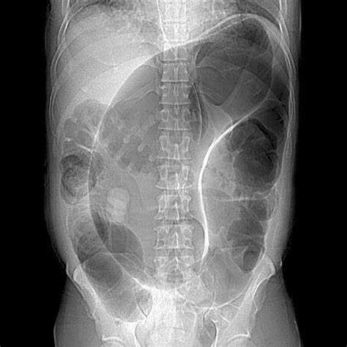
Stem: ER calls you to see an 83-year-old male presenting with severe, persistent upper abdominal pain, and multiple episodes of emesis over the past 48hr. He has dementia and lives in a nursing facility, so history is difficult to obtain.
Vitals : Tachycardic at 105, normotensive, afebrile.
Exam: His abdomen is distended and TTP in the LLQ but without guarding or rigidity.
Labs: WBC 12k, lactic of 2.0.
KUB is obtained, interpreted as “Grossly dilated colon. No evidence of pneumoperitoneum”

What is your differential diagnosis?
- Sigmoid Volvulus.
- Large bowel obstruction
- Cancer.
- IBD.
- Pseudo obstruction
What would you do for this patient, what is your work up diagnosis and management?
- Resuscitation
- Sigmoidoscopy for decompression (Resident must say they will do it themselves, not consult GI)
Additional Workup or Studies:
1. Family history of malignancy; Last colonoscopy
2. CT abdomen / pelvis with IV contrast → demonstrates sigmoid volvulus
What would you like to do now?
1. Two large bore IV’s, resuscitate the patient, +/- wound ostomy consult for stoma marking
2. Before proceeding to the operating room, are there any additional therapies that can be attempted or discussed?
a. non-operative decompression; would you be doing the flex sig?
You successfully detorse the patient and he begins feeling better. Now what?
- - Admit.
- - Bowel prep.
- - Ostomy marking.
- - Plan with Sigmoidectomy (Due to risk of recurrence)
  - All approaches acceptable, resident need to describe (open, lap , robotic .. primary anastomosis +/- diversion versus end colostomy.
Scenario: This same patient arrives and is diffusely TTP with evidence of guarding. He is febrile to 102 and has leukocytosis to 17k. What would you do differently?
1. proceed directly to OR for Sigmoidectomy.
Scenario: The patient from before that we just took to the operating room for the Hartmann’s; he is now POD3. You are called to the bedside by the wound ostomy nurse and with concerns about the appearance of the ostomy. She says the “Ostomy is dusky in appearance with patchy areas of blackness” How do you proceed?
1. Insert test tube or flexible scope to assess if necrosis descends below the level of the fascia
2. if the necrotic tissue does descend below the level of the fascia? → Patient needs a revision of their ostomy in the operating room, otherwise observe.
Scenario: This patient is a 58-year-old female with hx of HTN, HLD, 5 vaginal deliveries presenting with acute abdominal pain, and KUB demonstrating a distended air-filled cecum within the central abdomen. What is your approach to this patient?
1. Operative; no role for non-operative management or endoscopic.

AQ2 Sarcoma
Stem: A 55-year-old male presents to your office after being referred from his PCP for further valuation of an asymptomatic mass on his right inner thigh.
PMH: None. Family history is noncontributory.
PE: There is poorly defined posterior right thigh mass, approximately 8 cm in diameter (specify compartment, posteriormedial in this case based on picture, involving the hamstrings)
Labs: Not significant.

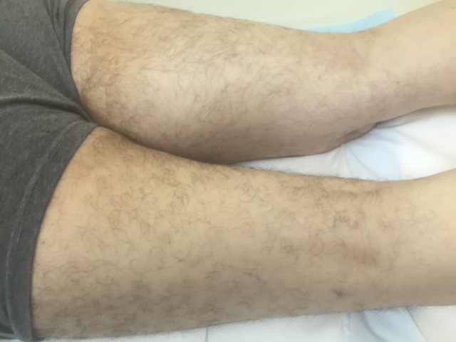
Describe how you would work up and manage this mass?
- Plain radiograph of the thigh: Soft tissue mass with fat density (Need to start with plain radiograph to r/o periosteal or bone involvement)
- MRI of the entire muscle compartment: Soft tissue mass, with low signal intensity on T1 and high signal intensity on T2
- Obtain image-guided core needle biopsy with multiple passes of 18g needle with site incorporated into possible resection margin → pathology: high grade pleomorphic sarcoma
- Staging workup: CT of chest
What if the core needle biopsy came back as non-conclusive? - Obtain incisional biopsy - describe Technique. - Along the axis and don’t develop fascial planes.
Mass is high grade, how would you approach this mass from an operative standpoint?
Radiate first
- limb salvage.
- Excision outside the pseudocapsule.
- Radical resection of the muscle compartment Preserve sciatic

When Is amputation indicated? - Inability to resect without amputation,
nonfunctional limb

Scenario : A 32-year-old man with a history of FAP presents with a 15-cm firm mass in the right axilla that restricts his range of motion. A CNB confirms a desmoid tumor, imaging doesn’t show nerve involvement, patient requests excision, how would you council them regarding risk of recurrence. ?

- >50% chance of recurrence even with R0 resection

What if the mass was asymptomatic? -
- Observe.
- Consider medical management with sulindac or other NSAIDs or tamoxifen.

What if this was a 32-year-old female and the mass was discovered during
pregnancy?
- Post-partum give sulindac or tamoxifen or observe.
- Most regress once hormonal stimulation removed.

Scenario 3: A 62-year-old man is seeing you in your office for the first time. He previously underwent exploratory laparotomy and resection of dedifferentiated liposarcoma 3 years ago and has now developed vague symptoms, including early satiety and abdominal bloating. He was lost to follow-up after his initial surgery. What would you recommend?
- Suspect recurrence
- Complete imaging workup including CT Chest/Abd/Pelvis

Your work up shows recurrence , when would recurrence be resectable?

In general, surgery is indicated if R1 resection possible

What if unresectable? recurrence → chemotherapy (ifosfamide/doxorubicin)

AQ3 Ventilator Associated Pneumonia VAP
Ventilator-Associated Pneumonia
Stem: A 28-year-old male sustained a significant traumatic brain injury (Glasgow Coma Scale of 8) after MVC, was intubated at site. Subsequent workup revealed multiple cerebral contusions. He was then admitted to the ICU and was managed with supportive care. On the 4th day following trauma, he mounted a febrile response to 101°F, had a new onset infiltrate in the right upper lobe, and developed leukocytosis.

What is Your Differential Diagnosis?
- VAP (Ventilator associated pneumonia)
- Pneumonitis.
- Pulmonary contusion.
- PE.
- ETT migration.
- Mucus plug
What would you like to do now?
- Antipyretics.
- ABG.
- Labs: WBC 16000
- CXR: Previously seen infiltrate, dense, ETT 4 cm above the carina.
- Bronchoscopy and quantitative bacteriology. (Sputum Gram stains or cultures are considered inappropriate as they are neither sensitive nor specific. The specimen used for quantitative bacteriology should be obtained either through a bronchoscope or by the use of a coaxial catheter called the mini-BAL)
Describe how to perform Bronchoscopy?
- Introduced the bronchoscope through an endotracheal tube.
- Advance to the level of the vocal cords.
- Careful inspection of the entire airway is performed.
- Effort should be made to avoid unnecessary contact with the mucosa to avoid trauma.
- Collect specimens.
- Final assessment of the airway should be performed ensure adequate hemostasis.
- A post-procedural chest x-ray
Patient started requiring higher FiO2 and PEEP, suction aspirate are mucopurulent , what would you like to do?
- Start vancomycin and Cefepime for VAP. (high risk of MRSA in ICU patients) until the quantitative cultures results.

